Run code on Android Studio

1.Install Node.js on computer

Down Node.js <https://nodejs.org/en/>, then execute it and follow guide to install it

2. Download Android Studio

<https://developer.android.com/studio/index.html#downloads>

Select computer platform to install it

3. Install Android SDK( Android 10 level 29)

Follow this guide

<https://developer.android.com/studio/releases/platforms>

4. Install Amplify on computer

After install Node/js, then you could install aws amplify command

Run npm install -g @aws-amplify/cli on terminal

5. Download Android project on Github

After download the android project, open android studio and open this project

6. Install virtual device on Android studio

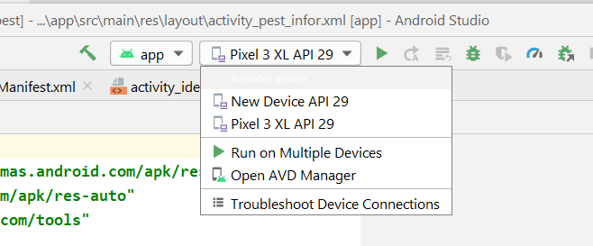

Open AVD Manager and select one device,



Select Level 29 then finish;

7. Run Android studio